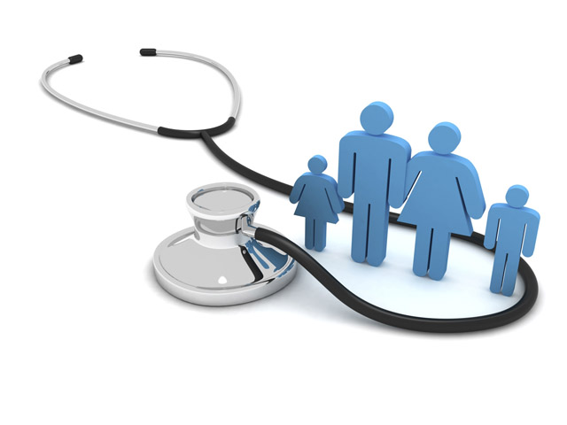

What to Do If You Feel Ill and Think You Need Help

If you feel unwell there are options available to you for treatment.
If you think you can cope with your illness, home treatments and medicines can be used.
Remember that you can help yourself and your family by taking preventative action.
However, if you feel ill and need further advice and support these are your options:

- Your local pharmacy
- Your medical centre
- Support over the phone or the web from NHS111
- Attending an Urgent Treatment Centre
- Calling 999 for Paramedic Support
- Attending Accident and Emergency

It depends how poorly you feel as to which you choose:
- Your Pharmacy – The Pharmacist can advise and treat common ailments, these include earache, sore throat for anyone over 5 years old and uncomplicated urinary tract infections for women (aged 16-64). The Pharmacist might prescribe medicines or suggest suitable proprietary ones. You can find more details at nhs.uk/thinkpharmacyfirst. If the Pharmacist thinks your condition is serious enough, they will refer you to your GP or other support.
- Your medical centre - Is of course still there for you and, if you can hold on through the phone queue at 8.00am or arrange a call-back, suitable care can normally be arranged.
- NHS111 - If the medical centre is closed or you think you might have an emergency then use NHS111 support. You can access this by telephone and online. NHS111 may refer you to clinicians that they have on site. NHS111 could arrange for you to attend an urgent treatment centre. If NHS111 think your case is serious enough they may call paramedics or send you to A&E. NHS111 can escalate your case to any of the care providers or raise your case to ‘999’ level.
- Urgent Treatment Centres – You can go directly to one of these centres (e.g. Darley Dale) or NHS111 may refer you to it. They are open 12 hours a day (8am until 8pm) for 365 days in the year.
- Ambulance / Paramedic Support - If you think your case is serious enough, for instance if you think you are having a stroke or heart attack, call 999. The paramedics can help decide the best treatment for you.
- Accident and Emergency – If you believe your condition is serious enough you can go directly to A&E.

